Kuberntes – Service
Kubernetes-Service-NodePort:
- We can expose an application running on a set of PODs using different types using Services available in K8s.
- ClusteIP (We can access the app within the cluster)
- NodePort ( We can access the app by using node’s IP along with port)
- LaodBalancer (This can be used while we are using cloud providers).
- NodePort Service
- To access our app outside of K8s cluster, we can use NodePort, we can use NodePort service.
- Exposes the Service on each Worker Node’s IP at static port (Nothing but NodePort).
- A ClusterIP Service, to which the NodePort Service routes, is automatically created.
- Port range 30000-32767.
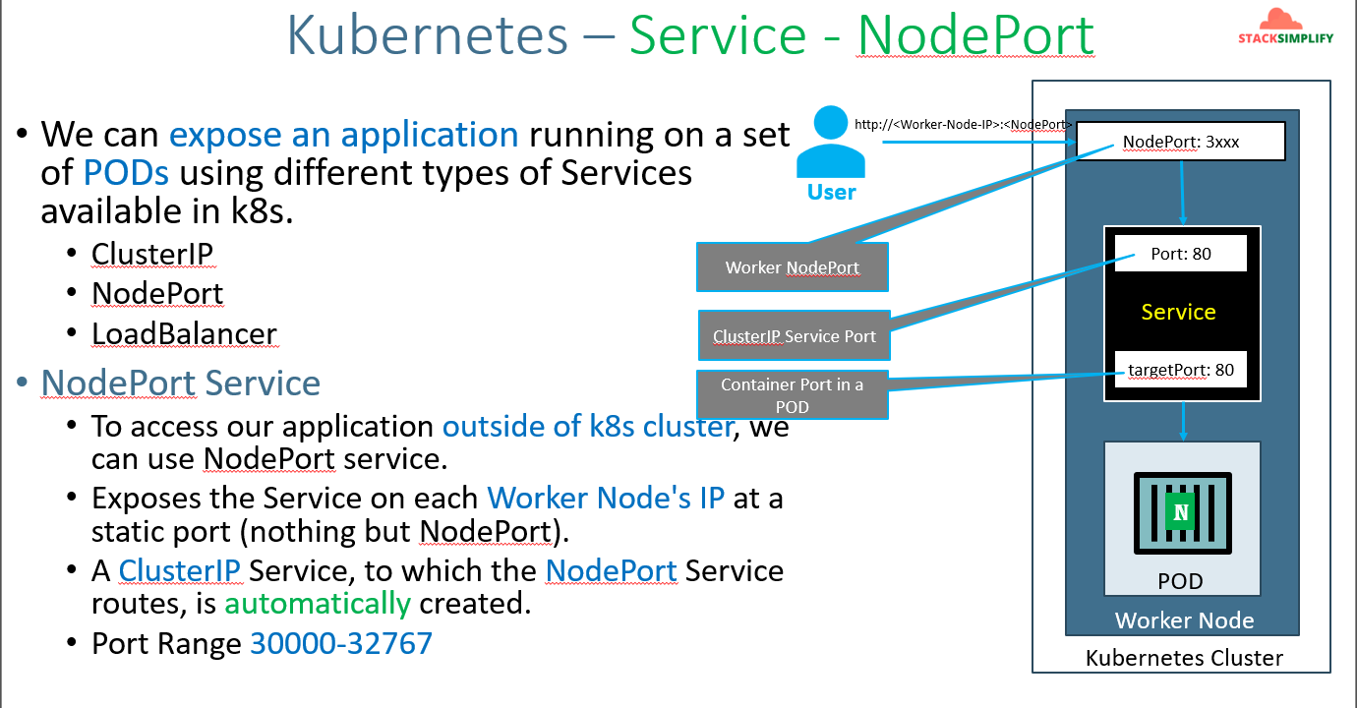
To expose pod by using NodePort service, please use below commands.
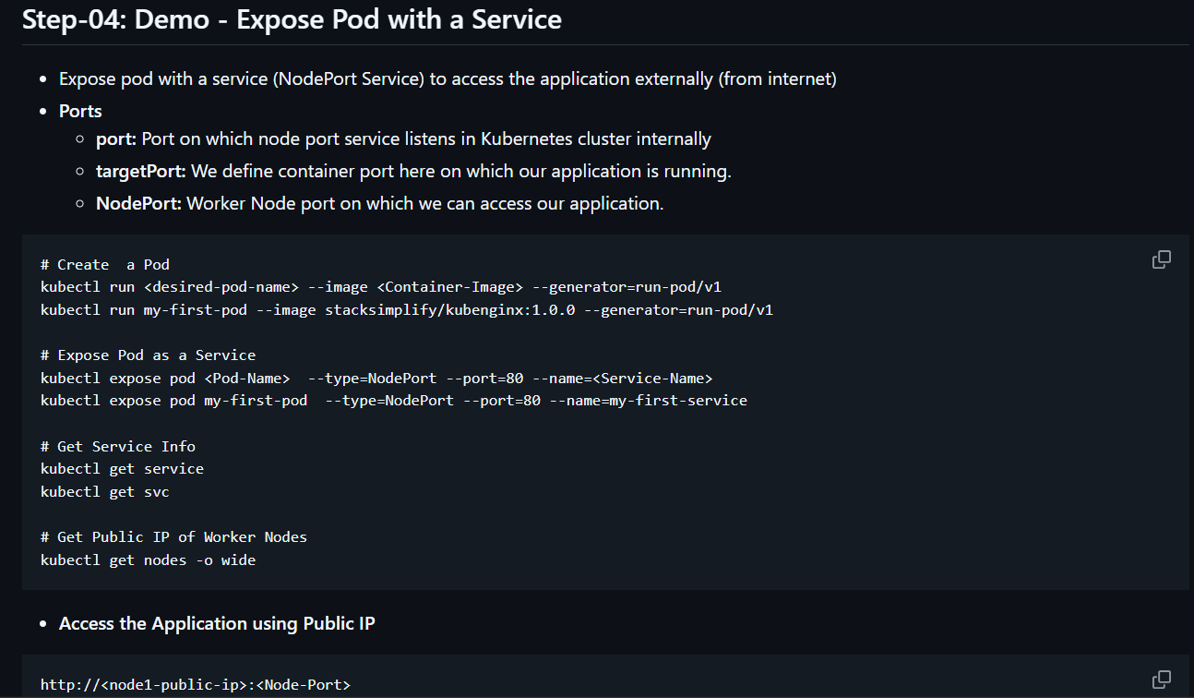
Our service is running. Now collect the external Ip of the node where our pod is running run on browser along with the NodePort <External-IP>:30945 .
Note:-
- Even if you try to access with another node’s External IP still we can access the app. Because the service is across the worker nodes.
- We need to allow the all traffic at node level “remote access” security group.
If you want to run the app on different clusterIP port use like below.
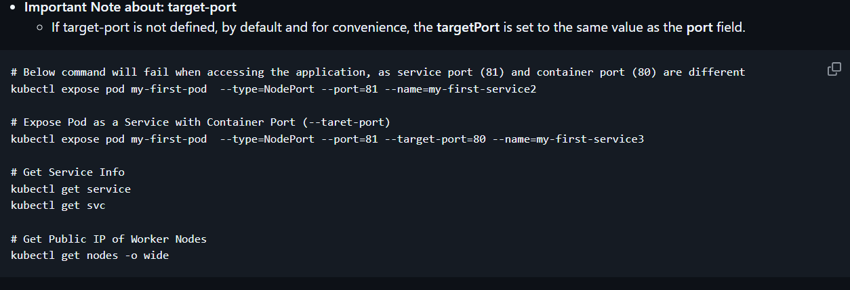
Interact with POD:
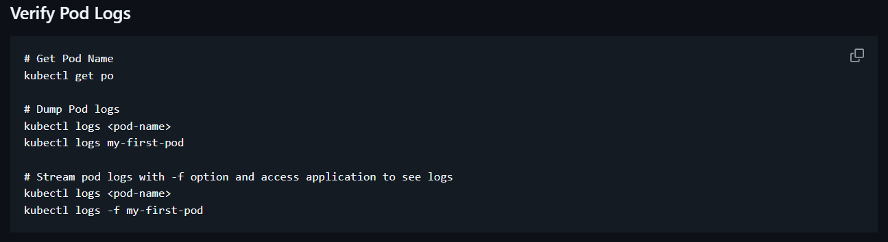
Kubectl commands cheatsheet kubectl Quick Reference | Kubernetes .
To check through which object the POD got created.
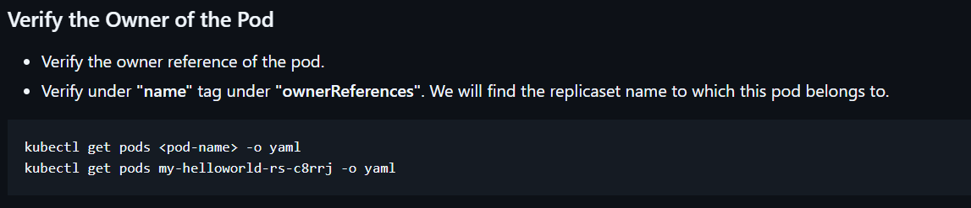
To expose ReplicSet as a service:
Run below commands
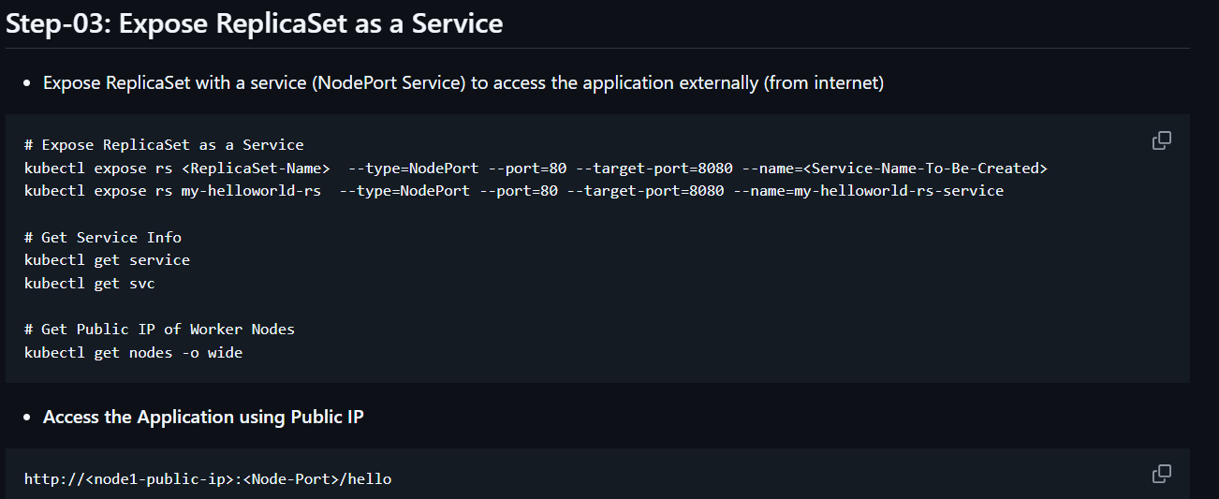
Deployment
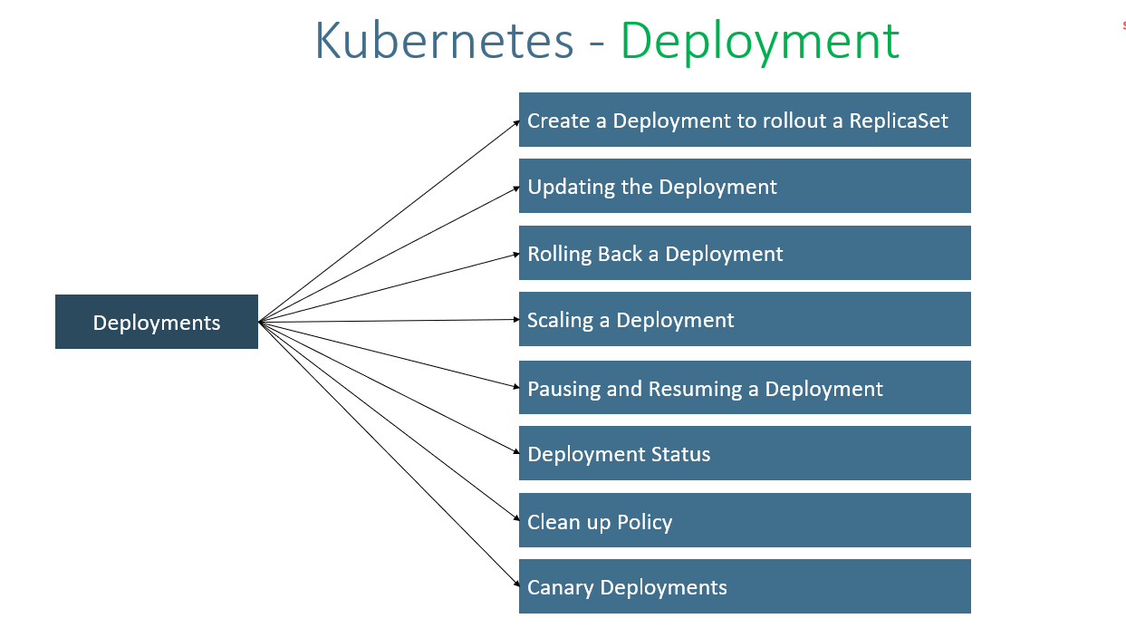
Create service with deployment by imperative way:-
Go through this link for more demonstration kubernetes-fundamentals/05-Services-with-kubectl at master · stacksimplify/kubernetes-fundamentals .

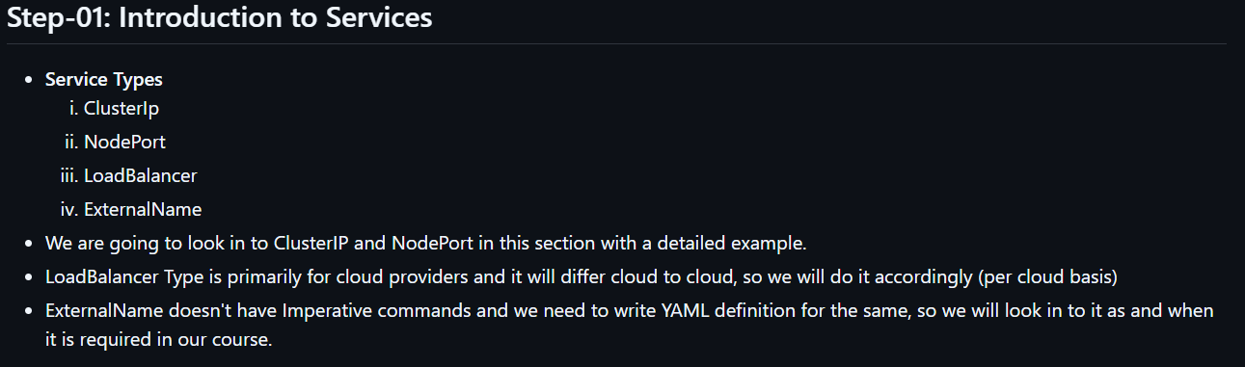
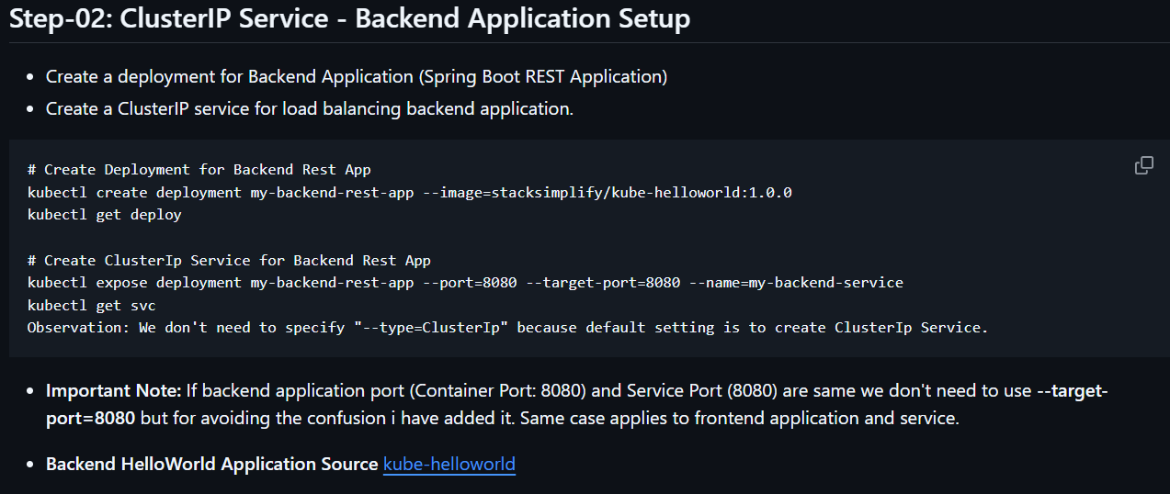
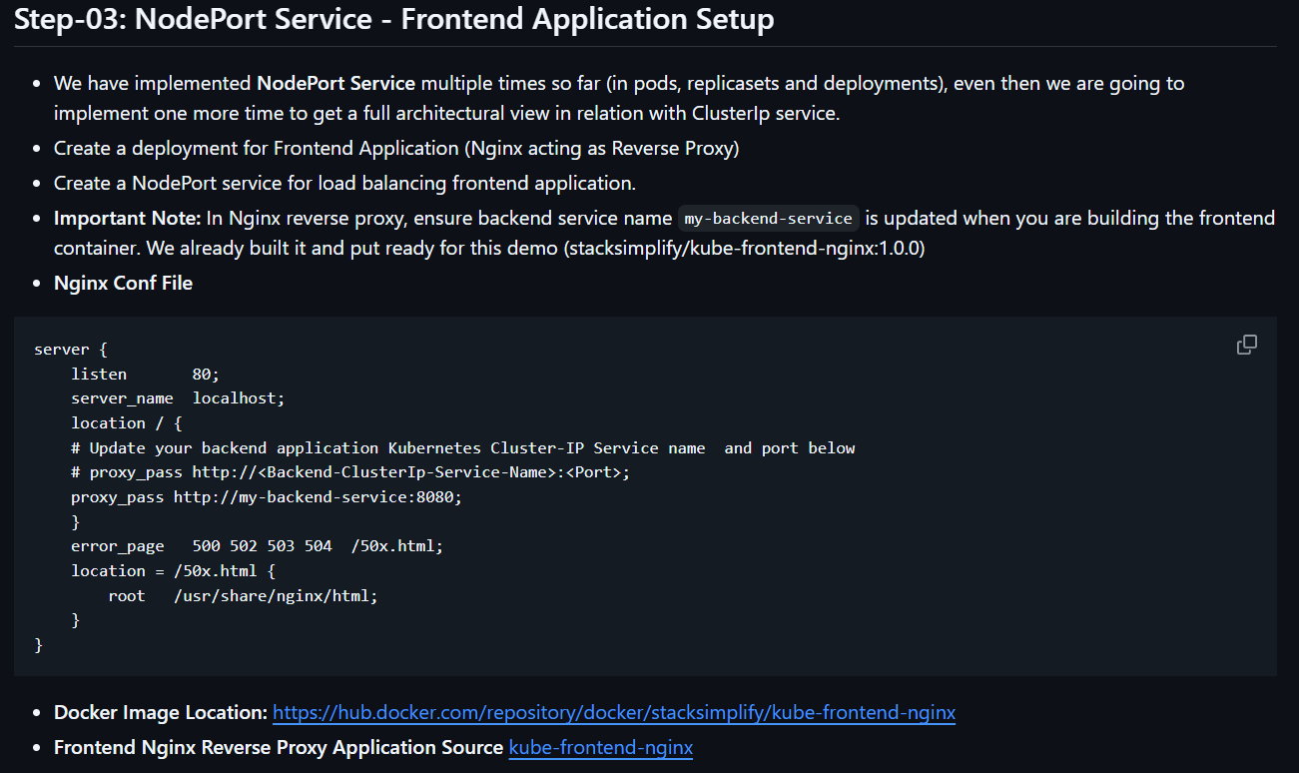
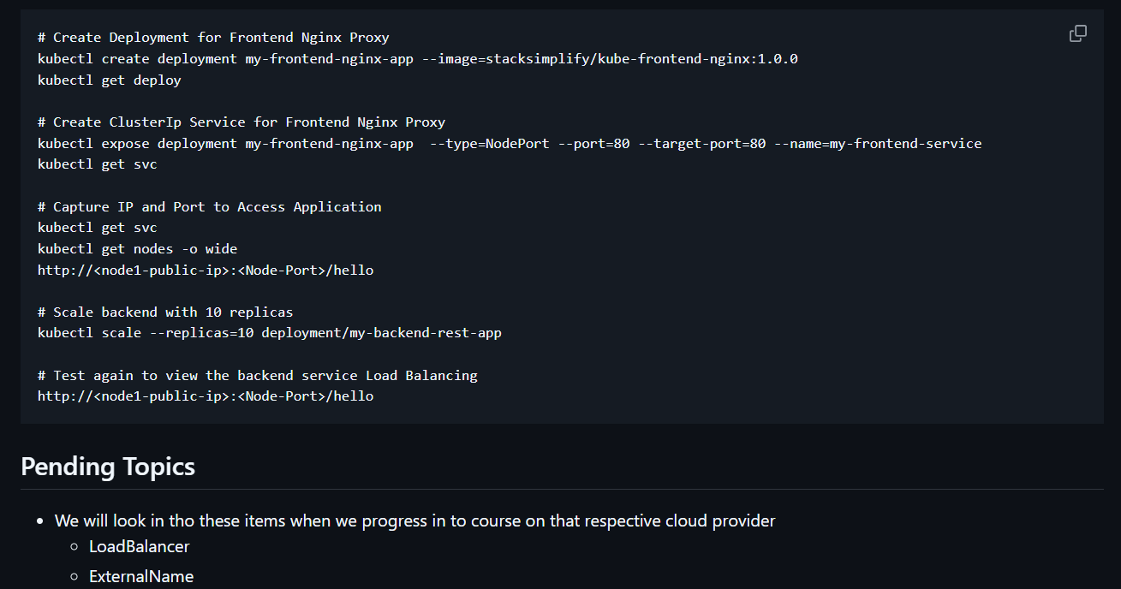
Follow the above mentioned steps you will create both ClusterIP (Backend) and NodePort(Frontend) services and try to access it from browser. If it’s not working then issue is with nodegroup SG allow all traffic with 0.0.0.0 .

